Newsletter of the 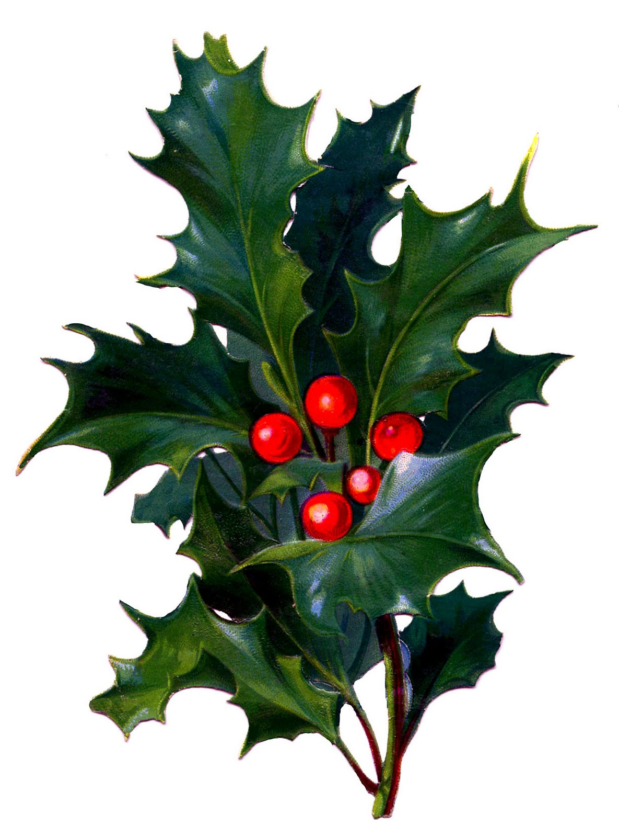
Capital Hudson Iris Society

Volume 25 Number 10 November-December 2018

Volum

Annual Holiday Party
Sunday, November 18 at 1:00

The Sunday, November 18th, 1:00 p.m. meeting of the Capital Hudson Iris Society will be our annual Holiday Party at the East Greenbush Community Library. Please come and bring a friend and a dish to share for the delicious potluck luncheon. Do remember that we begin early, at 1:00 p.m.

We’re making this our end of the year holiday party to avoid the December rush, so bring a festive dish to share. CHIS will provide the paper goods and beverages. If you want to participate in the gift exchange, bring a wrapped gift in the $15 price range and you’ll get to take home one for yourself. At the September meeting, we approved $300 for door prizes of gift certificates from a range of iris growers and local nurseries.

For those who have never partaken, this is a festive event not to be missed. CHIS has some serious cooks and everyone tries to bring something they really consider their specialty. There will be all sorts of hot luncheon items, side dishes, salads, and desserts. Please bring your dish in a microwavable container if it needs to be heated, or ovenproof if you want it in the oven for a few minutes. (It’s easier if it already comes in warm.) And don’t forget the serving implements needed for your dish. If you have any inspirations for table centerpieces, please by all means create them. And we would appreciate any tablecloths you can bring. Anything to help make the room look ready for a party is appreciated.

Any questions about the Holiday Party should be directed to Euthemia Matsoukas at euthemia@nycap.rr.com or 518 439-3758. Come to the party and bring a friend – there is always lots of food and the more the merrier! Remember, the festivities begin at 1:00, when the library opens.

The East Greenbush Community Library is located on Community Way off Michaels Road in East Greenbush, New York. If you need driving directions to the library, you can go online to www.eastgreenbushlibrary.org, hit “contact us” and in the lower right corner is a map and a way to access directions.

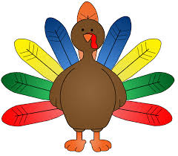

2018 Calendar

Sunday, November 18th, 1:00 p.m. (note early start time) HOLIDAY PARTY! We have an early party so we can avoid the December rush and the bad weather (we hope). Great potluck, gift-certificate door prizes, gift exchange (voluntary participation only), and a chance to relax before the onslaught of the holidays! Be sure to come, bring a friend, and a dish to share. If you’re new to the group and want to get to know some of us better, this is a good opportunity. We’ll also discuss possible changes to our spring sale at the meeting.

No meeting in December.

2019 Calendar

Sunday, January 20th , 2019, 1:30 p.m., Meeting at the East Greenbush Library. Speaker to be announced.

Sunday, February 17th, 11:30 a.m. Annual Doldrums Party held with the Upstate NY Hosta Society and the Hudson Adirondack Daylily Society. This is an annual potluck luncheon with a guest speaker. CHIS (that’s us!) is responsible for hosting this year. We’ll let you know who the speaker will be in the next newsletter. A really fun and educational event at a time when we’re all chomping at the bit to get back into our gardens!

Other dates in 2019:

Sunday, March 17th
Sunday, April 14th

Join the American Iris Society
www.irises.org

Linda says…

Dear Gardeners -

We had a very successful Region 2 Meeting on October 19 and 20 in Delmar. Bonnie Nichols, President of the Novelty Iris Society gave the keynote address and two separate judges training sessions. The potluck luncheon by CHIS was delicious. We also had great contributions from our club and individuals and clubs throughout the Region for the Silent Auction and earned over $800 for Region 2. Thanks to Region 2 members who came from western New York, the southern tier, and from as far away as Ontario! And to all who helped to plan for the speaker, accommodations, silent auction, food, and transportation, go the biggest thanks. It was an enormous job and we’re all still a little exhausted from it.

We’ll get to relax in November at our Holiday Party on Sunday, November 18. Just bring your favorite potluck luncheon dish and a gift if you want to participate in the gift exchange (see article on Page 1). December is meeting free. We’ll let you know about the January meeting and the February Doldrums meeting in the next newsletter (in the new year – yikes!).
- Linda

CHIS Contacts

CHIS Chair: Linda Knipper, Linda.Montanaro@gmail.com
518 377-4987

Vice Chairs: Dan and Joanne Maier, Danjomaier@gmail.com
518 449-8480

Secretary: Virginia Dorwaldt, vmdorwaldt@gmail.com
518 439-3110

Treasurer: Don Salhoff, driris2000@hotmail.com
518 439-1484

Newsletter editor: Euthemia Matsoukas, EuthemiaMatsoukas@gmail.com
Or euthemia@nycap.rr.com
518 439-3758

Iris Show Chair: Kathryn Mohr, kemohrke@aol.com
518 952-4995

CHIS Newsletter
November - December 2018
Volume 25, Number 10, page 2
Regional Meeting Report

CHIS held a very successful Region 2 Fall Meeting at the Delmar Presbyterian Church on Friday, October 19 and Saturday, October 20. Bonnie Nichols, President of the Novelty Iris Society, a new Section of the American Iris Society (official in 2015), gave the keynote address, “Novelty Irises: Looking Forward, Looking Back”. She came with beautiful and intriguing photos of novelty irises – and the varieties were fascinating. Flat flowers, irises with what is called broken color where the color bleeds due to planned viruses in the flowers, space age irises with horns and spoons (yes, spoons!), in a myriad of colors and in all categories of irises. Bonnie is a very dynamic and interesting speaker and kept the audience involved throughout. She also gave two judges trainings, one on Saturday morning at 8:30 on Awards and Ballots, and another following the keynote address on Judging Novelty Irises. Each of the judges training sessions had almost 20 participants, giving us hope that there will continue to be iris judges throughout the state available for our shows!

The Regional Meetings are always a big planning job, involving identifying a site; a speaker; arranging transportation and hotel accommodations; planning the food; getting the audio visual equipment and someone who knows how to work it; arranging the silent auction contributions, set up and final tallying; setting up the site before the meeting and cleaning up afterwards. Euthemia was mostly in charge of the logistics. But it was the teamwork and contributions from club members and Region members throughout the state that made it all come together. We couldn’t have done it without the help of Kathryn Mohr, CHIS member and the new Region 2 Vice President of AIS, who potted about 75 irises for door prizes and for the Silent Auction. Ann Vandervort was instrumental in creating a beautiful setting for the Silent Auction, assisting Dan Maier with this enormous job. Virginia Dorwaldt coordinated the food contributions and set up breakfast and lunch. Individual CHIS members all pitched in with food and muscle power. Wendy Roller and her husband Gary from the Greater Rochester Iris Society were also indispensible. Kathryn again jumped into it by agreeing to stay at the motel in order to take Bonnie to her 6:00 a.m. plane on Sunday morning – and you know that meant getting up at 4:00 a.m.!

At the general membership meeting on Saturday morning, it became clear that neither CHIS nor any of the other clubs have the manpower or inclination to take on the planning and expense of running such a big meeting. Stay tuned to hear about what the future will bring for Region-wide meetings. Changes are definitely coming.

